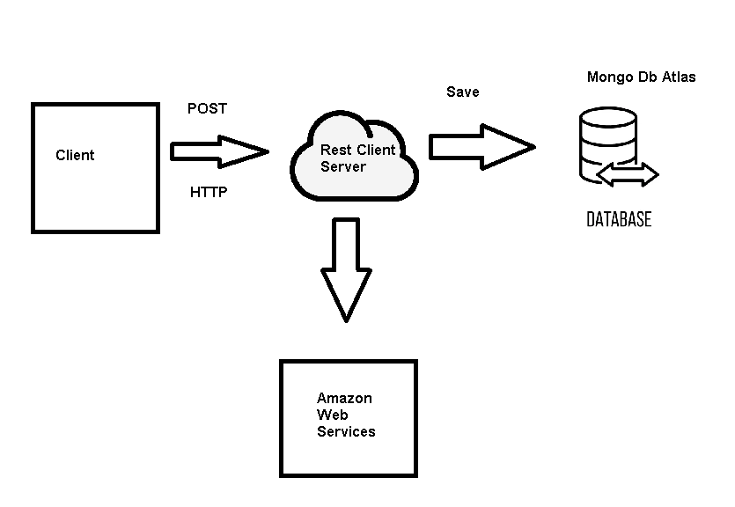

Uri Design

|  |  |
| --- | --- |
| **URI** | http://18.233.100.5:3016/newToy |
| **METHOD** | POST |
| **REQUEST** | **none** |
| PARAMS | none |
| BODY | {"id":1,  "name":” Hulk Toy”  "elaborationDate": 22-07-2022,  "available":true  } |
| TYPE | JSON |
| **RESPONSE** | **200** |
| PARAMS | N/A |
| BODY | Object Toy |
| TYPE | JSON |
| **DESCRIPTION** | This uri returns a json of the toy created into a mongodb database |

